CLEMSON TIGER PAW
You may have noticed the Clemson Tiger Paw on Ebay Recently. Pictured in several of the books it was thought to have not been mass produced..
An ebay seller has been selling a complete box of them (one at a time) that were found in South Carolina. The individual boxes are numbered and match the numbers on the larger box.

Shipping information shows they were shipped from the Nelson McCoy Pottery Company to J. B. Blackman, Jr. of Darlington,SC.
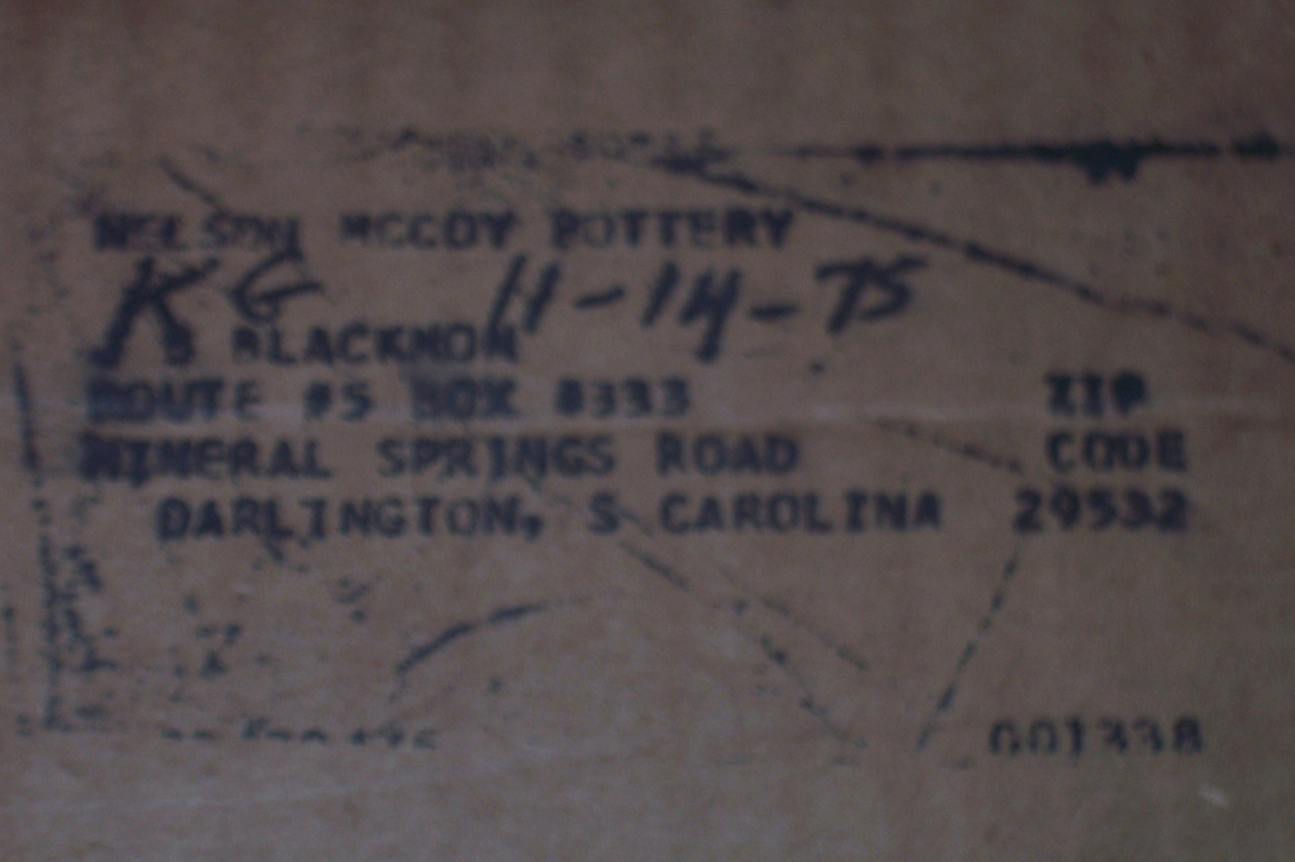

Each Statue has this sticker on the back.
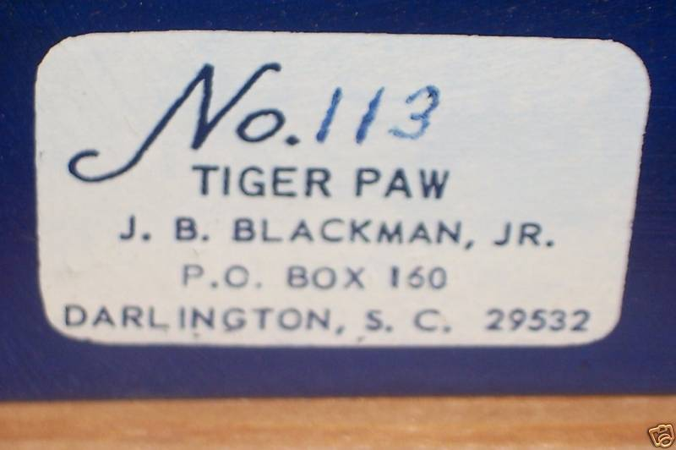
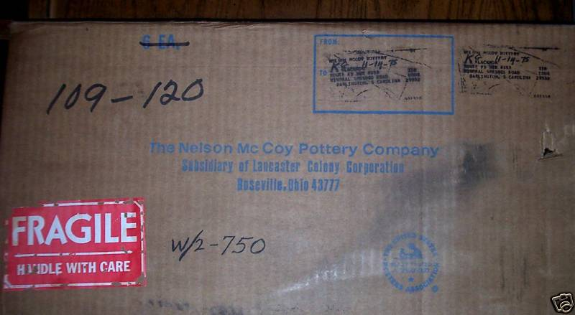

So it seems that Mr. Blackwell ordered these for alumni and possible was in charge of distribution. This must have been a left over box that surfaced recently.
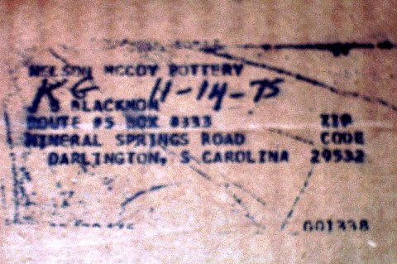
If the 11-14-75 is the date it fits right in with the Lancaster Colony Era.
Isn’t this fascinating? Wonder what will show up next! Box of Hillbilly Bears? Witches? NM Frogs?

